Eclipsing Binary Stars Worksheet
to follow the astronomy demonstration video at
https://www.youtube.com/watch?v=gmzmNDzUHEk

Part 1: The video describes four main representatives of the parameter space for eclipsing binary systems:

- Same Temperature, Same Size
- Same Temperature, Different Size
- Different Temperature, Same Size
- Different Temperature, Different Size

Examples of the theoretical light curves for each of these systems are shown below (for stars in circular orbits viewed edge-on i = 90°). Match each of the four lettered systems above to the appropriate light curve below by placing the matching letter in the box next to it.
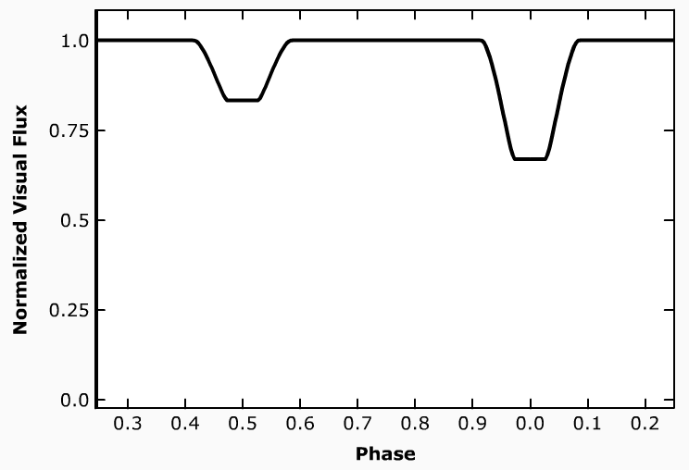
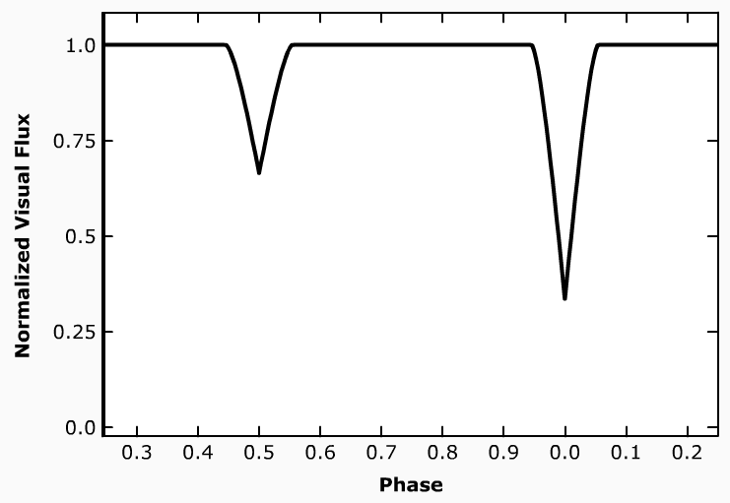

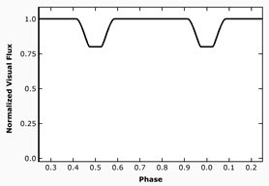
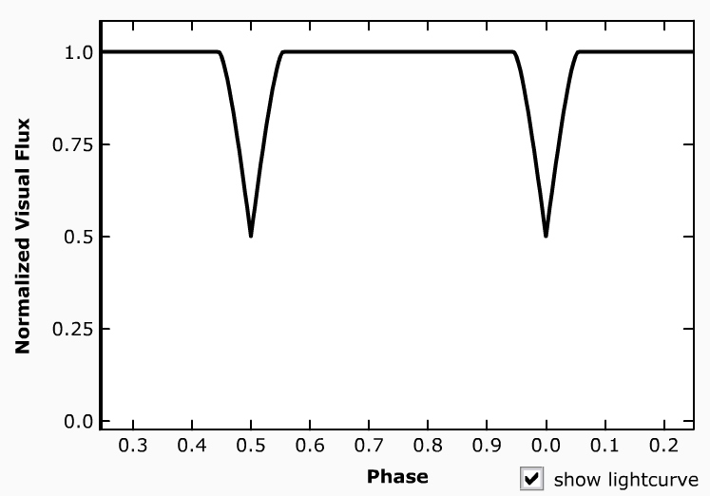

Part 2: Let’s explore the Same Temperature, Different Size light curve shown above. Note that during Eclipse A, the flux decreases to 0.80 (four-fifths) of the total (five-fifths) – and that is also true during Eclipse B. Use this information to exactly determine the relative sizes of the two stars. Fully explain your thinking.
Eclipse A

Eclipse B

Part 3 (Advanced Exploration): This section will use the Same Temperature, Same Size system to explore the large numbers of possible light curves. This system is shown below with an eccentric e = 0.5 orbit from an inclination of 0°. Light curves are provided below for this orbit from distant perspectives in the i=90° plane and with a smaller value of i. You are asked to provide an explanation detailing why this light curve “looks the way it does”.
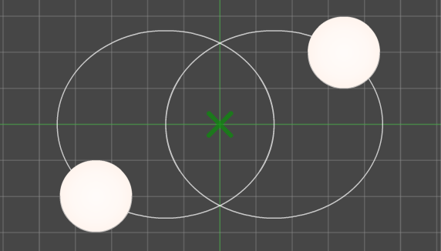

To
β

To
α

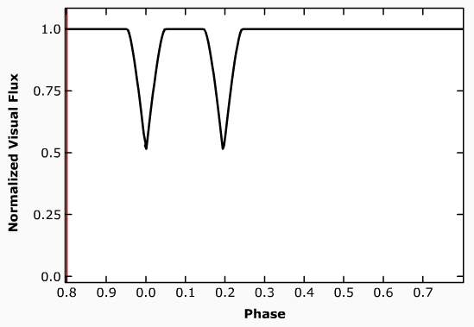
- From perspective α with an inclination i of 90°.

_________________________________________________

_________________________________________________

_________________________________________________

_________________________________________________

_________________________________________________

_________________________________________________

- From perspective β with an inclination i of 90°.

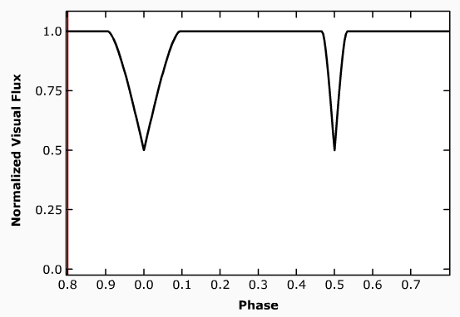
_________________________________________________

_________________________________________________

_________________________________________________

_________________________________________________

_________________________________________________

_________________________________________________
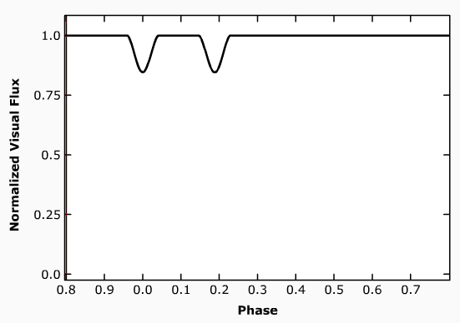
- From perspective α, then tilted to an inclination i of 75°.

_________________________________________________

_________________________________________________

_________________________________________________

_________________________________________________

_________________________________________________

_________________________________________________

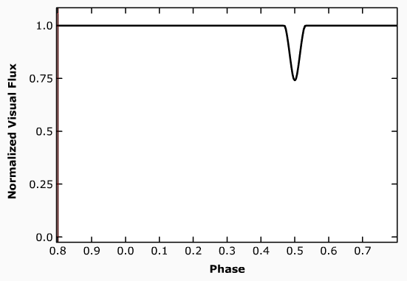
- From perspective β, then tilted to an inclination i of 75°.

_________________________________________________

_________________________________________________

_________________________________________________

_________________________________________________

_________________________________________________

_________________________________________________

