**Kepler’s Third Law Worksheet**

**to follow the video at**

<https://www.youtube.com/watch?v=84hi_NGqSow>

****Kepler’s third law provides a relation between the orbital period of a celestial body and the semi-major axis of its orbital path. When period **P** is in units of years and semi-major axis **a** in astronomical units it is an equality, but the proportionality is needed when using other units. One can form ratios for satellites orbiting the same central object and all proportionality factors cancel out. This allows us to conveniently compare orbits in any units that we wish.

Let’s explore the system of the Jupiter and the Galilean moons. The inner three moons (Io, Europa and Ganymede) have a 4:2:1 orbital resonance. In other words, it takes twice as long for Europa, Jupiter's second-closest moon, to orbit Jupiter as it does Io, the closest moon. And, in turn, the third-closest moon, Ganymede, takes four times as long as Io to orbit Jupiter. So they tend to pass each other periodically at the same point of their orbits.

Let’s investigate how far away Europa and Ganymede are from Jupiter in terms of Io’s semi-major axis. We will describe the steps (and illustrate them with a fictitious moon) and you should implement them in table rows below. A calculator is not needed.

1. Write the orbital periods (P) of Europa and Ganymede in terms of the period of Io in the table below. As an example, a moon with an orbital resonance of 3 would be described by: 
2. Divide the orbital period of each moon by that of Io. For the example moon: 
3. Square the previous value. For the example moon: 
4. Apply Kepler’s Third Law. For the example moon:  which we know is 9.
5. Take the cube root of the value in column 4. A lookup table is provided. For the example moon, the cube root of 9 is 2.08 yielding: 
6. Rearrange to solve for the semi-major axis of the moon in terms of Io’s orbit. 

|  | 1. P | 2. | 3. | 4. | 5. | 6. |
| --- | --- | --- | --- | --- | --- | --- |
| Io |  | 1 | 1 | 1 | 1 |  |
| Europa |  |  |  |  |  |  |
| Example |  | 3 | 9 | 9 | 2.08 |  |
| Ganymede |  |  |  |  |  |  |

|  |  |
| --- | --- |
| Cube Roots | |
|  |  |
| 1 | 1 |
| 4 | 1.59 |
| 8 | 2 |
| 9 | 2.08 |
| 16 | 2.52 |
| 27 | 3 |

1. Using the results you found in column 6 of the table, complete the diagram below of Jupiter and the orbits of the inner three Galilean moons in Jupiter’s equatorial plane below. You should assume circular orbits. Io has already been included.

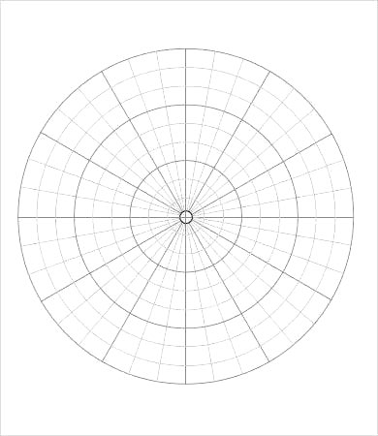

Jupiter

Io

Closing Thoughts

Comparing the orbits of two bodies that orbit the same central body using Kepler’s Third Law is very useful as it can be done in the most convenient units and proportionality factors cancel out. This is the reason that P2=a3 is valid for objects orbiting the sun when done in units of years and AU, because the object in the denominators of the ratios is Earth.

Although the eccentricities of the orbits of Io, Europa, and Ganymede are small and ignored in this video and worksheet, they turn out to be very significant. This is covered in another Astronomy Demonstration Video “The Tidal Heating of Io”.